

**DECLARATION ON HONOUR BY THE LEGAL REPRESENTATIVE OF THE APPLICANT ORGANISATION**

**To be completed by the person legally authorised to sign on behalf of the applicant organisation**

1 2

I, the undersigned, *Authorisedrepresentative*, authorised to represent the*Applicant organization*, hereby



request from the Agency a grant of EUR *Grant* *requested*3 with a view to implementing the action

4



*"Project title"*on the terms laid down in this application.



I certify that the information contained in this application is correct and complete and that the organisation I represent has not received any other Union funding to carry out the action/work programme which is the subject of this grant application.

I certify on my honour that the organisation I represent is not in one of the situations which would exclude it from participation in the grant award procedure and accordingly declare that the organisation

1. represent:
   1. isnot bankrupt or being wound up, isnot having itsaffairs administered by the courts, has not entered into an arrangement with creditors, has not suspended business activities, is not the subject of proceedings concerning those matters, or is not in any analogous situation arising from a similar procedure provided for in national legislation or regulations; 
   2. has notbeen convicted of an offence concerning itsprofessional conduct by a judgment of a competent authority of a Member State which has the force of *res judicata*; 
   3. has not been guilty of grave professional misconduct proven by any means which the Agency/Commission can justify including by decisions of the EIB and international organisations; 
   4. is in compliance with its obligations relating to the payment of social security contributions or the payment of taxes in accordance with the legal provisions of the country in which itis established or with those of the country of the responsible Authorising Officer or those of the country where the grant agreement/decision is to be performed; 
   5. has not been the subject of a judgment which has the force of *res judicata* for fraud, corruption, involvement in a criminal organisation, money laundering or any other illegal activity, where such illegal activity is detrimental to the Union' financial interests; 
   6. is not subject to an administrative penalty for being guilty of misrepresenting the information required as a condition of participation in a procurement procedure or another grant award procedure or failing to supply this information, or having been declared to be in serious breach of its obligations under contracts or agreements covered by the Union's budget. 

I have been informed that the organisation I representwill not be granted financial assistance if, in the course of the grant award procedure, it:

1. issubject to a conflict of interests; 
2. isguilty of misrepresentation in supplying the information required by the Agency as a condition of participation in the grant award procedure, or fail to supply this information. 
3. findsitselfin one of the situations of exclusion listed above. 

I declare that the organisation I represent:

1. will inform the Agency/Commission, without delay, of any situation considered a conflict of interests or which could give rise to a conflict of interests; 
2. has not granted and will not grant, has not sought and will not seek, has not attempted and will not attempt to obtain, and has not accepted and will not accept any advantage, financial or in kind, to or from any party whatsoever, where such advantage constitutes an illegal practice or involves corruption, either directly or indirectly, inasmuch as it is an incentive or reward relating to the award of the grant. 

I acknowledge that according toArticle 131 of the Financial Regulation of 25 October 2012 on the financial rules applicable to the general budget of the Union (Official Journal L 298 of 26.10.2012, p. 1) and Article 145 of its Rules of Application (Official Journal L 362, 31.12.2012, p.1) any applicant organisation found guilty of misrepresentation or found to have seriously failed to meet its contractual obligations under a previous contract award procedure may be subject to administrative and financial penalties under certain conditions.

I declare that the organisation I representis fully eligible in accordance with the criteria set out in the General Call for proposals. 

I certify that the organisation I representhas the financial and operational capacity to carry out the proposed action/work programme. 

If selected to be awarded a grant, the organisation I representaccepts the standard conditions as laid down in the grant agreement/decision. 

In the event that my grant application is successful, I am aware that the Education, Audiovisual and Culture Executive Agency / European Commission will publish on its website or in any other appropriate medium:

 the name and locality of the beneficiary of the grant;



* the amount awarded; 
* thenature and purpose of the grant. 

By signing this application form, I accept all the conditions set out in the "Europe for Citizens" programme guide (2014-2020), as published on the Education, Audiovisual and Culture Executive Agency's website.

Name / first name:*NAME,* *First name* FATIMA MAHMOOD



Title or position in the applicant organisation:*Title or Position* PROSPECTIVE STUDENT

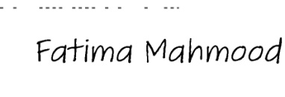

Signature [and official stamp] of the applicant:

HEADMISTRESS

Date:*02/02/2018* GSEC TANDALIANWALA



FAISALABAD DIST

Your reply to the grant application will involve the recording and processing of personal data (such as your name, address and CV), which will be processed pursuant to Regulation (EC) No 45/2001 on the protection of individuals with regard to the processing of personal data by the Community institutions and bodies and on the free movement of such data. Unless indicated otherwise, your replies to the questions in this form and any personal data requested are required to assess your grant application in accordance with the specifications of the call for proposals and will be processed solely for that purpose by the responsible Controller. For the purpose of this provision, the "Controller" is the person who has represented the Agency for the purpose of the signature of this grant agreement/decision. Personal data

may be transferred on a need to know basis to third parties involved in the evaluation of applications or in the grant management procedure, without prejudice of transfer to the bodies in charge of monitoring and inspection tasks in accordance with European Union law. Details concerning the processing of

your personal data are available on the privacy statement at the page:

http://eacea.ec.europa.eu/about/documents/calls_gen_conditions/eacea_grants_privacy_stateme nt.pdf.

Your personal data may be registered in the Early Warning System (EWS) only or both in the EWS and Central Exclusion Database (CED) by the Accounting Officer of the Commission, should you be in one of the situations mentioned in:

* the Commission Decision 2008/969 of 16.12.2008 on the Early Warning System (for more information see the Privacy Statement on http://ec.europa.eu/budget/contracts_grants/info_contracts/legal_entities/legal_entities_en.cfm ), or
* the Commission Regulation 2008/1302 of 17.12.2008 on the Central Exclusion Database (for more

information see the Privacy Statement on http://ec.europa.eu/budget/explained/management/protecting/protect_en.cfm#BDCE )

June 2017

OOD

**Declaration on honour**

The undersigned [*insert name of the signatory of this form*],1 representing the following legal person:

Full official name: FATIMA MAHMOOD

|  |  |  |
| --- | --- | --- |
| Official legal form: | 1-NATURAL PERSON 2- LEGAL PERSON 3 FINANCAL STATEMENT | |
| Statutory registration number**:** | PIC 999612161 PIC 909452795 | PIC 909011833 |

|  |  |  |
| --- | --- | --- |
| Full official address: | HOUSE NO 687 B ,BATALA COLONY ,FAISALABAD ; PAKISTAN |  |
| VAT registration number: |  |
| GB 918037524 COVENTRY UNIVERSITY UK |  |
|  |  |

authorised to represent the [applicant organisation/consortium,]1 hereby requests from the Educational, Audiovisual and Culture Executive Agency (hereinafter referred to as "the Agency") a grant2of EUR [*insert amount of the* *requested EU grant*]1with a view to implementing the [[*insert name of the project*]] on the terms laid down in thisapplication and

(1) declares that [the] [each] applicant is fully eligible in accordance with the criteria set out in the call for

proposals;



YES

(2) declares that the applicant[s] [has] [have] the financial and operational capacity to carry out the proposed

[action] [work programme];



YES

(3) declares that [the applicant has not] [none of the applicants have] received any other Union funding to carry out the [action] [work programme] subject of this grant application and commits to declare immediately to

the Agency any other such Union funding it would receive until the end of the [action][work programme].



YES

(4) declares whether [the] [each] applicant is in one of the following situations or not [(if yes, please indicate

the name of the concerned applicant(s) if any in annex to this declaration)]:



YES

|  |  |  |  |  |
| --- | --- | --- | --- | --- |
| **SITUATION OF EXCLUSION CONCERNING [THE] [EACH] APPLICANT** | |  | YES | NO |
|  |  |  |  |  |
| a) | it is bankrupt, subject to insolvency or winding up procedures, its | assets are being |  |  |
|  | administered by a liquidator or by a court, it is in an arrangement with creditors, its business | |  |  |
|  | activities are suspended or it is in any analogous situation arising from a similar procedure | |  |  |
|  | provided for under national legislation or regulations; |  |  |  |
|  |  |  |  |  |
| b) | it has been established by a final judgement or a final administrative | decision that the |  |  |
|  | applicant is in breach of its obligations relating to the payment of taxes or social security | |  |  |
|  | contributions in accordance with the law of the country in which it is established, with those of | |  |  |
|  | the country in which the authorising officer is located or those of the country of the | |  |  |
|  | performance of the contract; |  |  |  |
|  |  |  |  |  |



1 A detailed Privacy statement on the processing of the personal data of the applicant(s), including contact information, is

available on EACEA's website:

http://eacea.ec.europa.eu/about/documents/calls_gen_conditions/eacea_grants_privacy_statement.pdf

1. it has been established by a final judgement or a final administrative decision that the applicant is guilty of grave professional misconduct by having violated applicable laws or regulations or ethical standards of the profession to which the applicant belongs, or by having engaged in any wrongful conduct which has an impact on its professional credibity where such conduct denotes wrongful intent or gross negligence, including, in particular, any of the following:
   1. fraudulently or negligently misrepresenting information required for the verification of the absence of grounds for exclusion or the fulfilment of selection criteria or in the performance of a contract, a grant agreement or a grant decision;
   2. entering into agreement with other persons with the aim of distorting competition;
   3. violating intellectual property rights;
   4. attempting to influence the decision-making process of the Agency during the award procedure;
   5. attempting to obtain confidential information that may confer upon it undue advantages in the award procedure;
2. it has been established by a final judgement that the applicant is guilty of any of the following:
   1. fraud, within the meaning of Article 1 of the Convention on the protection of the European Communities' financial interests, drawn up by the Council Act of 26 July 1995;
   2. corruption, as defined in Article 3 of the Convention on the fight against corruption involving officials of the European Communities or officials of EU Member States, drawn up by the Council Act of 26 May 1997, and in Article 2(1) of Council Framework Decision 2003/568/JHA, as well as corruption as defined in the legal provisions of the country where the authorising officer is located, the country in which the applicant is established or the country of the performance of the contract;
   3. participation in a criminal organisation, as defined in Article 2 of Council Framework Decision 2008/841/JHA;



1. money laundering or terrorist financing, as defined in Article 1 of Directive 2005/60/EC of the European Parliament and of the Council;



* + 1. terrorist-related offences or offences linked to terrorist activities, as defined in Articles 1 and 3 of Council Framework Decision 2002/475/JHA, respectively, or inciting, aiding, abetting or attempting to commit such offences, as referred to in Article 4 of that Decision;
    2. child labour or other forms of trafficking in human beings as defined in Article 2 of Directive 2011/36/EU of the European Parliament and of the Council;

1. it has shown significant deficiencies in complying with the main obligations in the performance of a contract, a grant agreement or a grant decision financed by the Union’s budget, which has led to its early termination or to the application of liquidated damages or other contractual penalties, or which has been discovered following checks, audits or investigations by an Authorising Officer, OLAF or the Court of Auditors;
2. it has been established by a final judgment or final administrative decision that the applicant has committed an irregularity within the meaning of Article 1(2) of Council Regulation (EC, Euratom) No 2988/95;
3. in the absence of a final judgement or where applicable a final administrative decision, the applicant is in one of the situations provided in (c) to (f) above based on:
   1. facts established in the context of audits or investigations carried out by the Court of Auditors, OLAF or internal audit, or any other check, audit or control performed under the responsibility of an authorising officer of an EU institution, of a European office or of an EU agency or body;
   2. non-final administrative decisions which may include disciplinary measures taken by the competent supervisory body responsible for the verification of the application of standards of professional ethics;
   3. decisions of the ECB, the EIB, the European Investment Fund or international organisations;
   4. decisions of the Commission relating to the infringement of the Union's competition rules



2

or of a national competent authority relating to the infringement of Union or national competition law.

1. decisions of exclusion by an authorising officer of an EU institution, of a European office or of an EU agency or body.



***[Only for legal persons other than Member States and local authorities, otherwise delete this table]***

1. declares whether a natural person who is a member of the administrative, management or supervisory body of [the] [each] applicant, or who has powers of representation, decision or control with regard to that applicant (this covers the company directors, members of the management or supervisory bodies, and cases where one person holds a majority of shares) is in one of the following situations or not [(if yes, please indicate the name of the concerned applicant(s) and natural person(s) if any in annex to this declaration)]:

|  |  |  |  |
| --- | --- | --- | --- |
| **SITUATIONS OF EXCLUSION CONCERNING PERSONS WITH POWERS OF REPRESENTATION,** | YES | NO |  |
| **DECISION OR CONTROL OVER THE APPLICANT** |  |
|  |  |  |
|  |  |  |  |
| Situation (c) above (grave professional misconduct) |  |  |  |
|  |  |  |  |
| Situation (d) above (fraud, corruption or other criminal offence) |  |  |  |
|  |  |  |  |
| Situation (e) above (significant deficiencies in performance of a contract ) |  |  |  |
|  |  |  |  |
| Situation (f) above (irregularity) |  |  |  |
|  |  |  |  |



1. declares whether a natural or legal person that assumes unlimited liability for the debts of the applicant[s] is in one of the following situations or not [(if yes, please indicate the name of the concerned applicant(s) and natural or legal person(s) if any in annex to this declaration)]:

|  |  |  |  |  |
| --- | --- | --- | --- | --- |
| **SITUATIONS OF EXCLUSION CONCERNING NATURAL OR LEGAL PERSONS** | YES | NO | Not |  |
| **ASSUMING UNLIMITED LIABILITY FOR THE DEBTS OF THE APPLICANT** | Applicable |  |
|  |  |  |
|  |  |  |  |  |
| Situation (a) above (bankruptcy) |  |  |  |  |
|  |  |  |  |  |
| Situation (b) above (breach in payment of taxes or social security contributions) |  |  |  |  |
|  |  |  |  |  |



(7) declares whether [the] [each] applicant is in one of the following situations or not:

|  |  |
| --- | --- |
| **GROUNDS FOR REJECTION FROM THIS PROCEDURE** | YES NO |

1. has provided accurate, sincere and complete information to the Agency within the context of this



grant procedure;

(8) acknowledges that the applicant[s] may be subject to rejection from this procedure and to



administrative sanctions (exclusion or financial penalty) if any of the declarations or information YES provided as a condition for participating in this procedure prove to be false.

**REMEDIAL MEASURES**

If [the] [any] applicant declares one of the situations of exclusion listed above, it should indicate the measures it has taken to remedy the exclusion situation, thus demonstrating its reliability. They may include e.g. technical, organisational and personnel measures to prevent further occurrence, compensation of damage or payment of fines.

3

The relevant documentary evidence which appropriately illustrates the remedial measures taken should be provided in annex to this declaration. This does not apply for the situations referred in point (d) of this declaration.

**EVIDENCE UPON REQUEST**

Upon request and within the time limit set by the Agency [the] [any] applicant shall provide information on the persons that are members of the administrative, management or supervisory body, as well as the following evidence concerning the applicant or the natural or legal persons which assume unlimited liability for the debt of the applicant:

For situations described in (a), (c), (d) or (f), production of a recent extract from the judicial record is required or, failing that, an equivalent document recently issued by a judicial or administrative authority in the country of establishment of the applicant showing that those requirements are satisfied.

For the situation described in point (a) or (b), production of recent certificates issued by the competent authorities of the State concerned are required. These documents must provide evidence covering all taxes and social security contributions for which the applicant is liable, including for example, VAT, income tax (natural persons only), company tax (legal persons only) and social security contributions. Where any document described above is not issued in the country concerned, it may be replaced by a sworn statement made before a judicial authority or notary or, failing that, a solemn statement made before an administrative authority or a qualified professional body in its country of establishment.

If [the] [any] applicant already submitted such evidence for the purpose of another procedure, its issuing date does not exceed one year and it is still valid, the applicant shall declare on its honour that the documentary evidence has already been provided and confirm that no changes have occurred in its situation.

If selected to be awarded a grant, the applicant[s] accept[s] the general conditions as laid down in the published grant [agreement] [decision].

Full name Date Signature

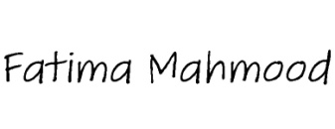

FATIMA MAHMOOD 03/02/2018

4

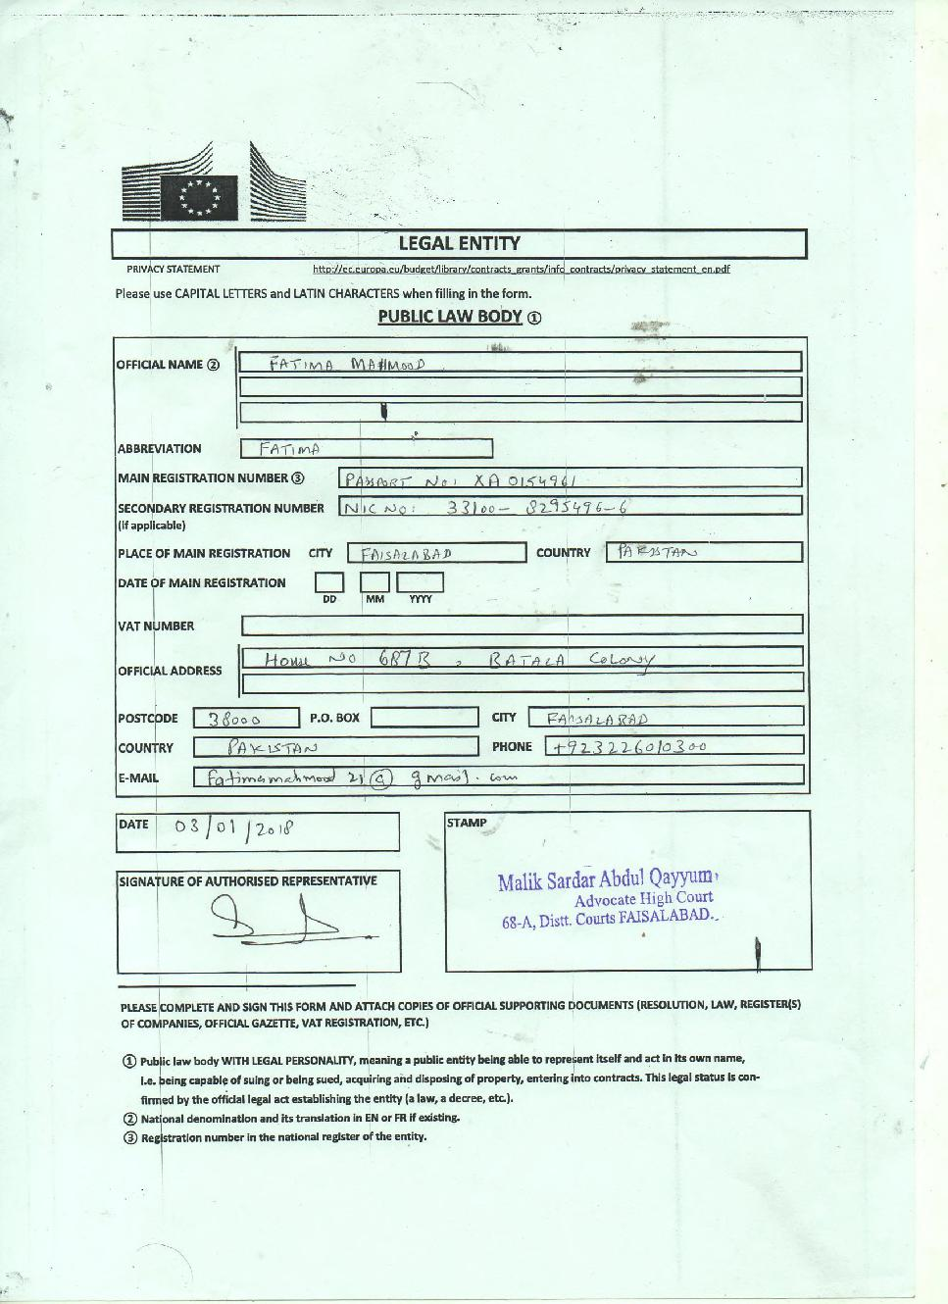

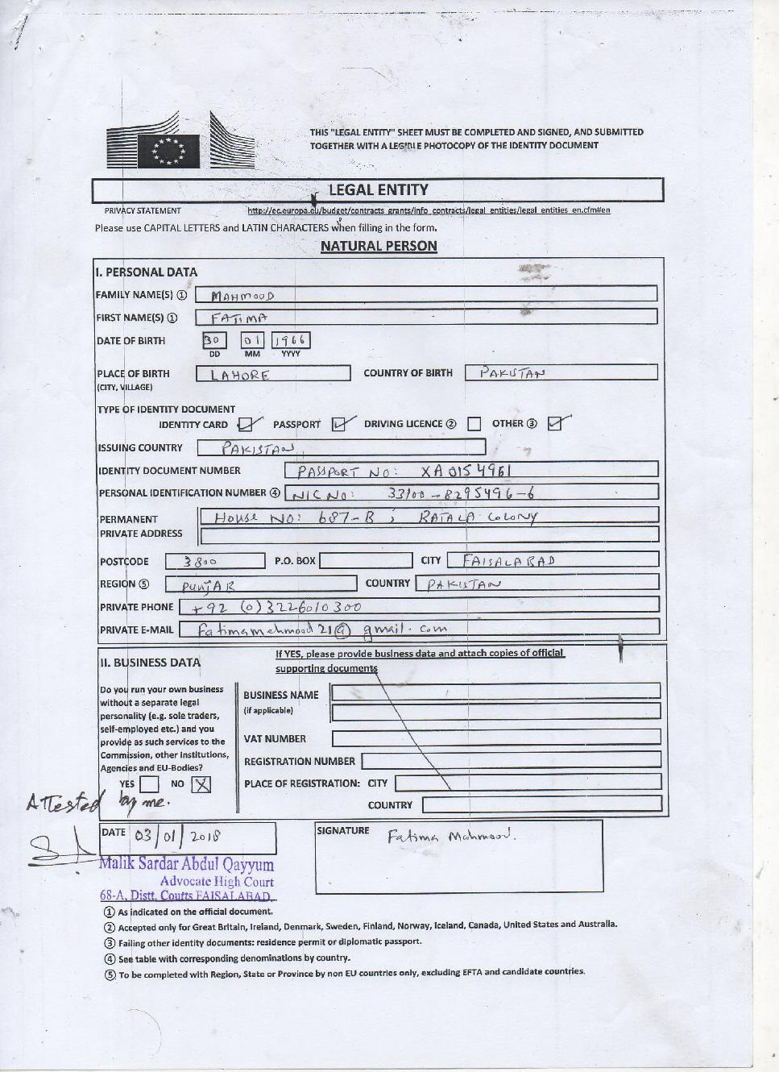

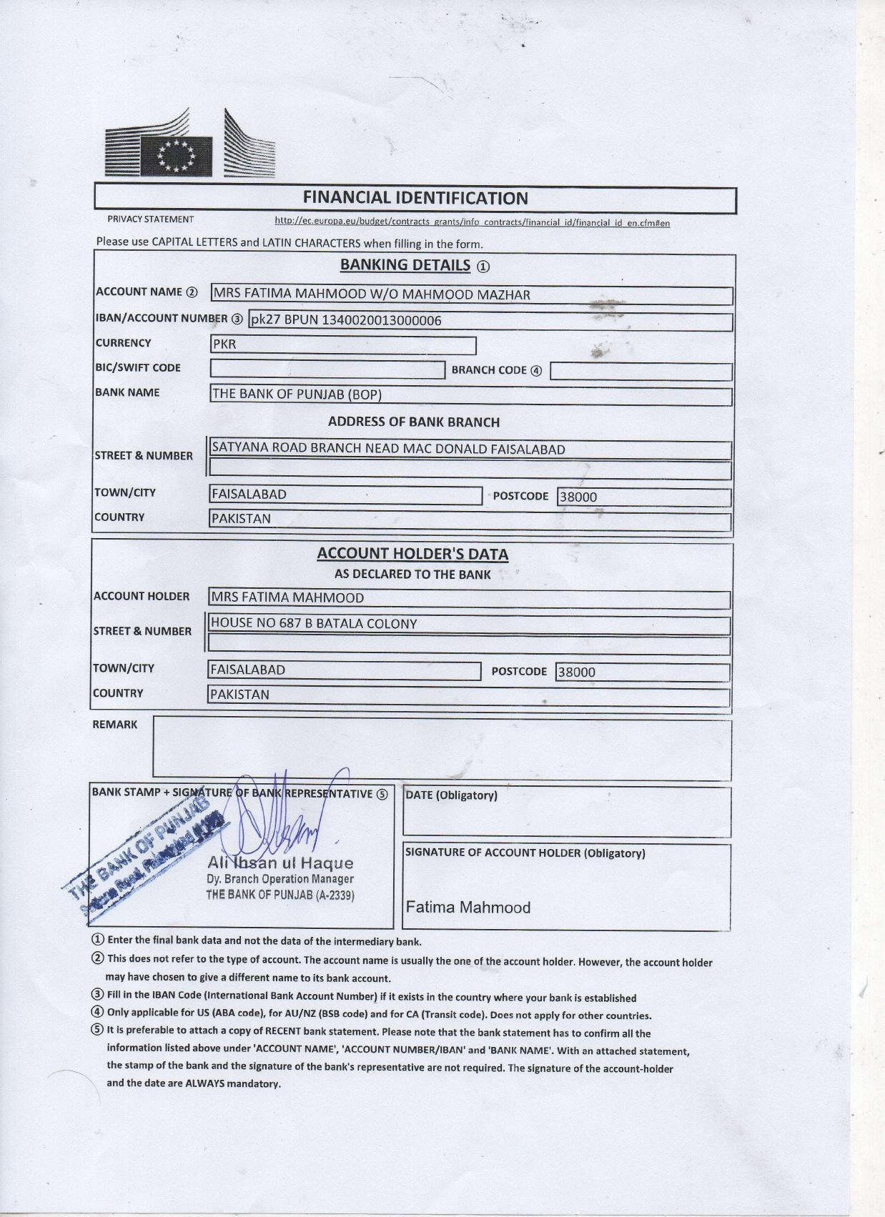



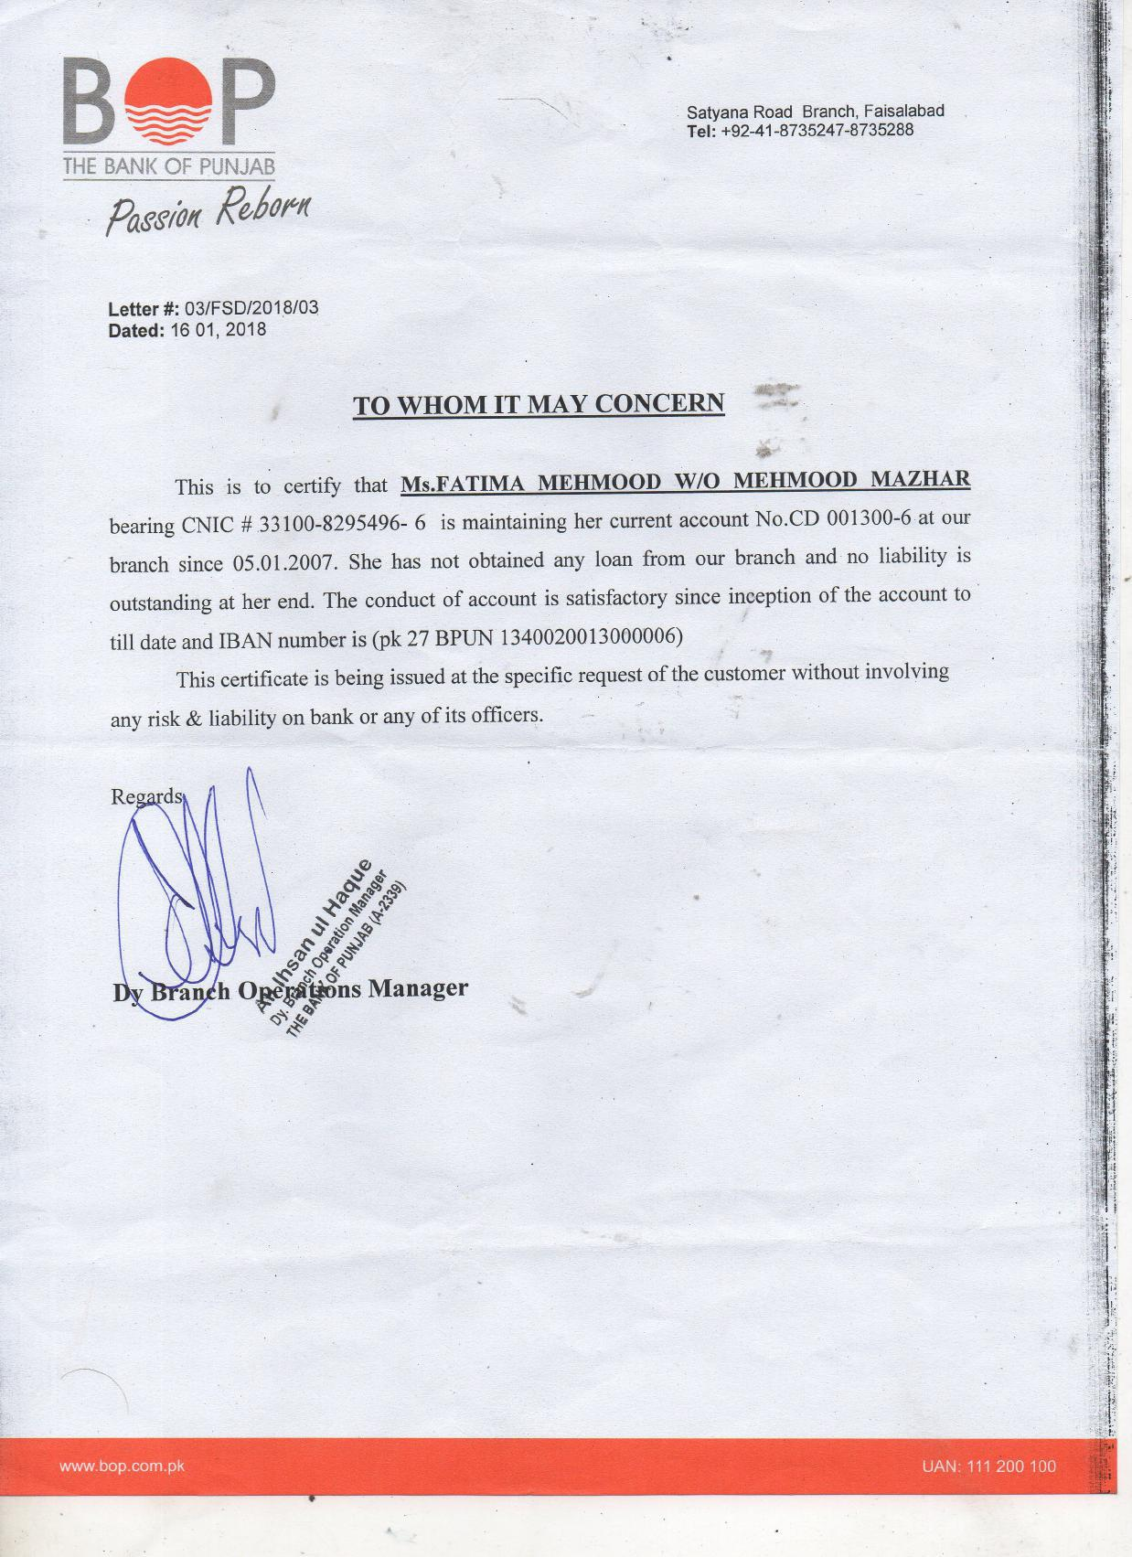

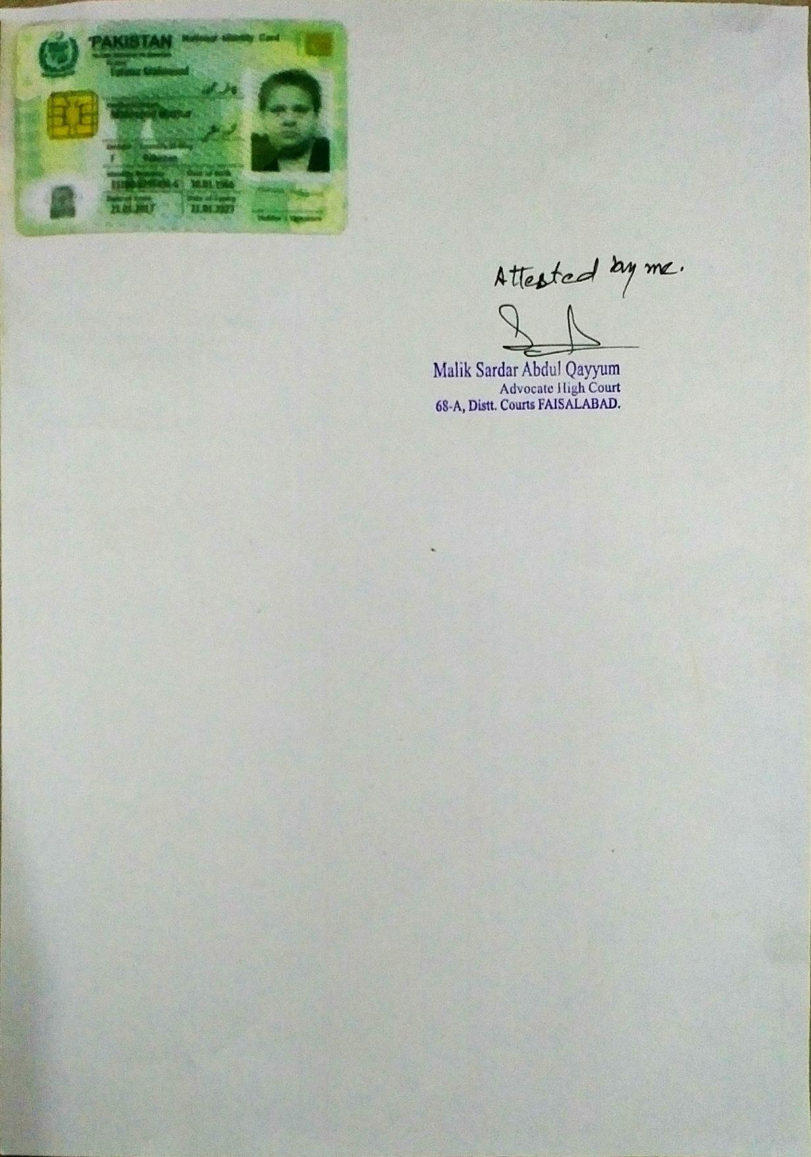





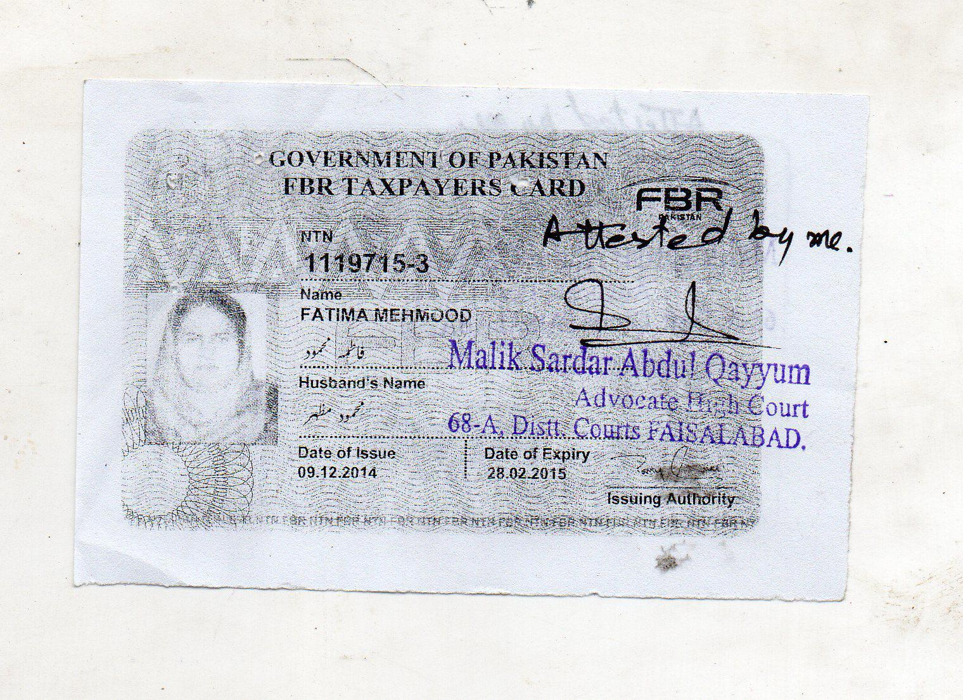





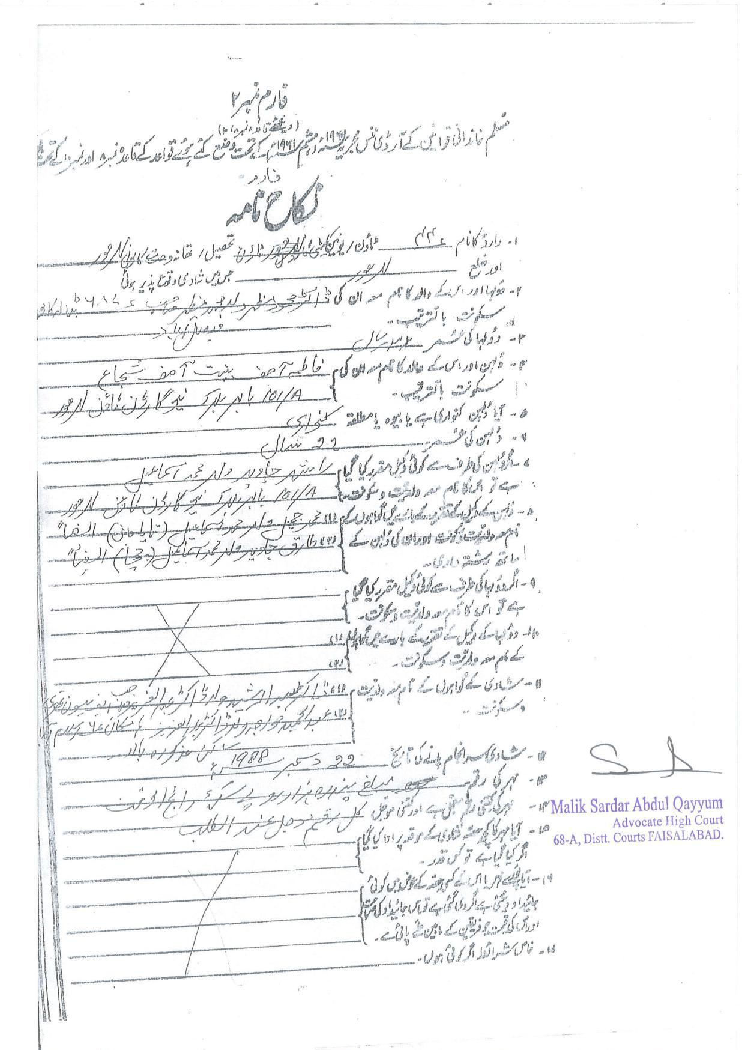

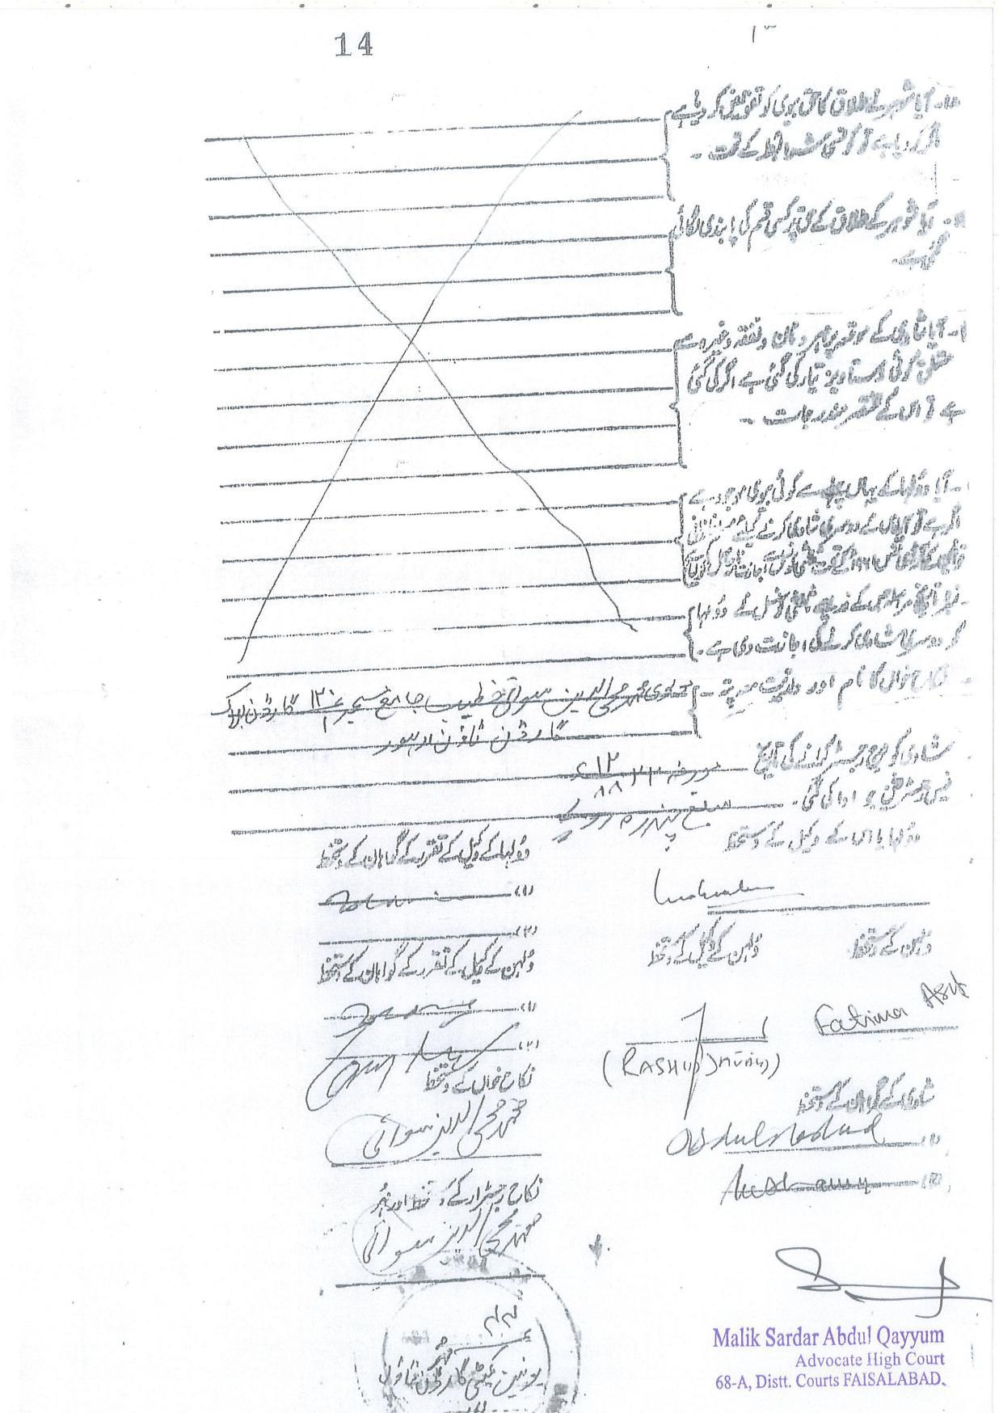

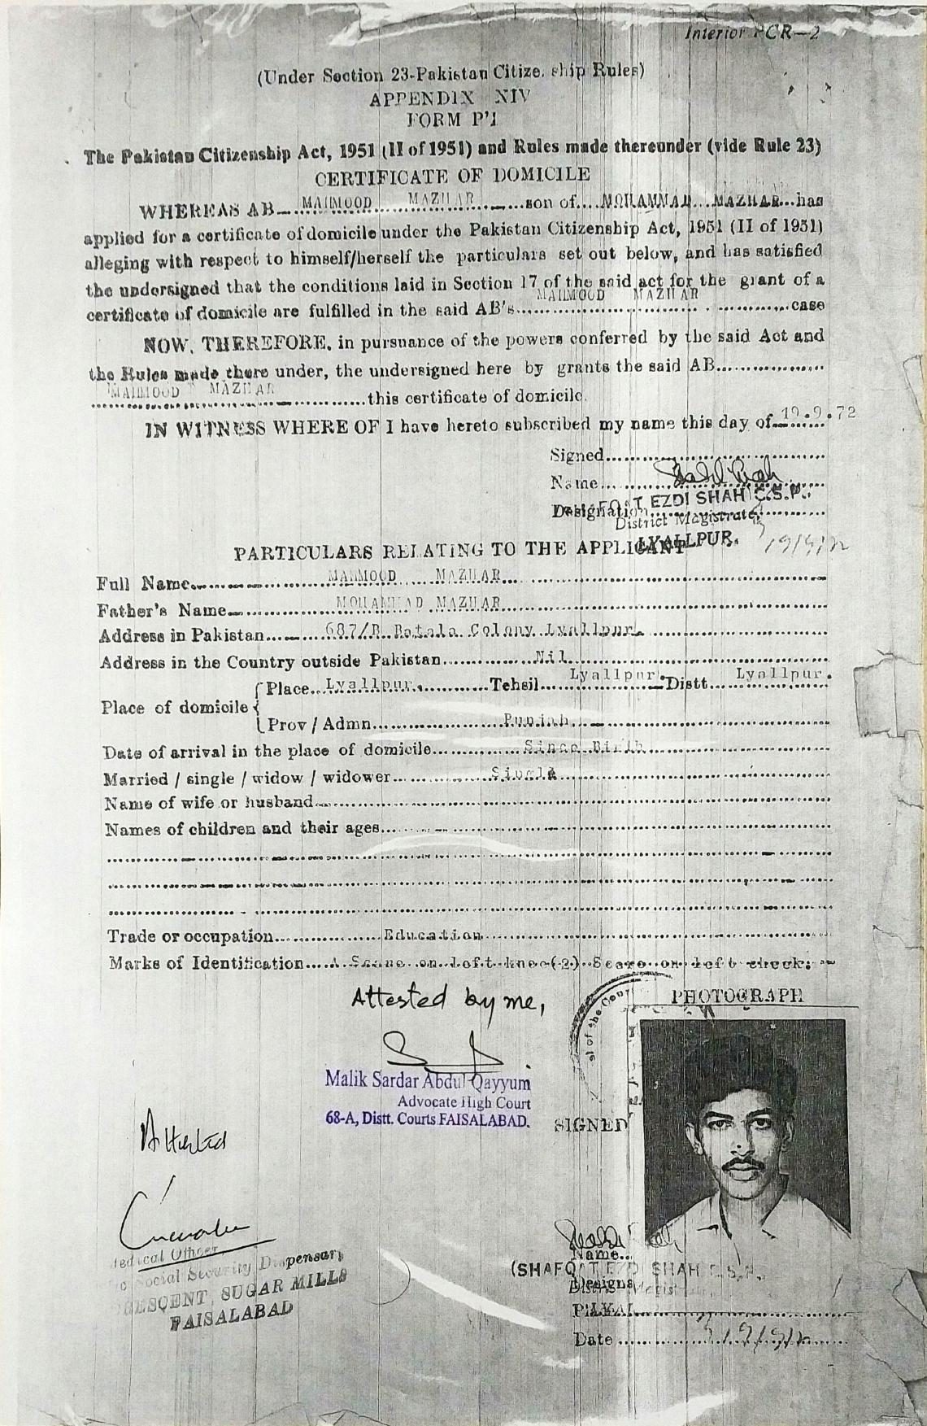

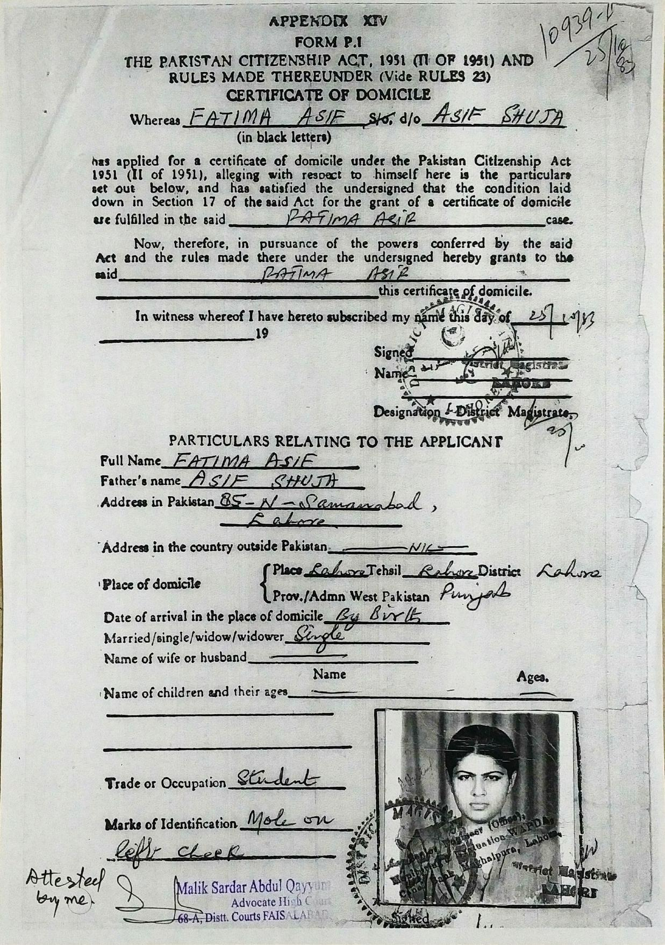

**CV**

**ABOUT ME**

**NAME: Fatima Mahmood** **PH NO +92418726233: CELL: +923226010300**

**WEB ADDRESS: https://www.linkedin.com/in/fatima-mahmood-815196119/ EMAIL ADDESS fatimamahmood21@gmail.com**

**Hello outlook 71068E74D5EB46E1@outlook.com**

**ADRESS: HNO 687 B BATALA COLONY FAISALABAD PUNJAB PAKISTAN**

**Technical Skills Likes: Educational, Educational Administration and Management, Educational research, Morelikethis**

**Job Experience**

**October 2005 – Current**

**Headmistress Govt Special Education Center Faisalabad District - Govt Special Education Department Punjab Pk**

**Administrative Head DDO**

**Administration, Organization, Control, Leadership,**

**Teaching Disable Children, Discipline, Planning**

**Representation, Financial Head,, Decision Making**

**EDUCATION**

**I have studied and has good knowledge of subjects like statistics and applied**

**Research the subjects were part of my various course work i had wrote up to 6 research articles these and mini theses during my studies and job i have good**

**Grip of report writing and data analysis i win award certificate issue by IJSER my Research published in IJSER USA and i achieved ODI and publishing award**

**1 Fatima Mahmood[1988]” Dimensions Of Stress In Early Parenting” ordinary published deposited at Punjab university Applied Psychology Dept. Library, Pakistan**

**2 Fatima Mahmood [1988]Survey and Collaborative work on’ Drug Addiction’ Ordinary Published deposited at University of the Punjab Applied Psychology Department Library Pakistan**

**3 Fatima Mahmood [1988] Thesis Desert ‘ 4 Clinical Cases ‘, A Report On Case History, Diagnosis Therapeutic Treatment And Follow Up visits of Psychiatric patients of Mental Hospital and Mayo Hospital Lahore , Ordinary Published deposited at University of the Punjab Applied Psychology Department Library Pakistan**

**4 Fatima Mahmood [2005] Thesis ; Hearing Aid a Tool in the Rehabilitation of Hi ordinary published deposited in AIOU Special Education Department Library Pakistan**

**5 Fatima Mahmood [2016] 'Effectiveness of Special Education in Educating Special Children of Government Special Education Center Faisalabad district' IJSER USA may 2016 vol7 issue 5 ISSN 2229-5518 http://www.ijser.org/researchpaper-publishing-may-2016_page6.aspx prefix IJSER DOI: 10.14299/000000**

**6 Fatima Mahmood [2016] ‘Use Of Audiovisual Aids Improve Performance of HI Children of Class Kg1 K.G2 &Form 1 In Subject Like Math and General Knowledge ‘ordinary published deposited in GCUF Distant Learning Education dept. Library Pakistan**

**I am working on for the completion of MPHIL Special Education**

1. **Fatima Mahmood [2017] Thesis Desert,” A Comparative Study on The Student Services Available At GOVT**

**And Private Special Education Institutions present In Faisalabad District ,Punjab Pakistan” from GCUF Distant Learning Education Department Faisalabad PK.**

**Certifications**

**1979 – 1981**

*SSC/ MATRIC A GRADE*

**1981 – 1983**

*HSSC/FSC*

**1983 – 1985**

*B.A PSY& PHILOSOPHY LCW P.U LAHORE PK*

*Psychology philosophy*

1ST DIV

**Education 1985 – 1987**

*M.Sc. Applied Psychology - PU PK*

*clinical academic*

earn 1st division Thesis on mental patients Research study Survey practice in survey on drug addiction

**1994 – 2005**

*MED SP.EDU - AIOU ISLAMABAD PK*

*teaching disabled children HI/MR*

COMPLETED ON JOB -65% MARKS 1ST DIVISION

**2013 – 2014**

*B.ED special education - GCUF PK*

*google-apps-for-education*

A—grade with Distinction 3.91/4 marks teaching practice with special children

Assignments completed presentation/seminar attended attend classes with

More than 70% attendance

**2015 – 2017**

*MPhil student special education - GCUF PK*

*computer-vision research educational*

working on theses, student

Attachment: cv.docx - Page 1 of 1

Ref: SN09660/4003946WR Fatima Mahmood

**ON JOB TRAINING COURSES**

|  |  |  |  |
| --- | --- | --- | --- |
| SPEECH THERAPY SHORT COURSE | UNIVERSITY OF THE | JUN 2005 | B |
| 3 MONTHS DURATION | PUNJAB PK |  | GRADE |
|  |  |  |  |
| 7 ADMINISTRATIVE COURSES | GOVT INSERVICE | DEC2005 – | GOOD ON 5 |
|  | TEACHER OF | JAN 2015 | PONT RATING |
|  | DISABLED PERSON |  | SCALE |
|  | TRAINING COLLEGE |  |  |
|  | GITTC LAHORE PK |  |  |
|  |  |  |  |
| WORKSHOPS ATTENDED | VARIOUS ON JOB |  | PARTICIPATIO |
|  |  |  | N |
|  |  |  | CERTIFICATE |
|  |  |  |  |

REFRENCE

|  |  |
| --- | --- |
| Name Mr. Akmal Shaw | Name Dr Mahmood Mazhar |
| [ MA MED Special Education] | [MBBS,MSC Audiological Medicine UCL |
|  | London UK] |

|  |  |  |  |
| --- | --- | --- | --- |
| Position | Senior Special Education | Position | Consultant Medical Audiologist |
|  | Teacher |  | And Director |
|  | SST |  | Audiology Unit |
|  |  |  | Register Alumni UCL London |
|  |  |  |  |
|  |  |  |  |
| Organization | Govt Special Education | Organization |  |
|  | School [ Middle Level] |  | Ear Clinic And Rehabilitation Unit |
|  | Tandalianwala Punjab Govt. |  | For Deaf |
|  | Education |  |  |
|  | Department |  |  |
|  |  |  |  |

|  |  |  |  |
| --- | --- | --- | --- |
| Address | Govt Special Education | Address | House No 687 B Batala Colony |
|  | School [Middle Level] |  | Faisalabad |
|  | Tandalianwala |  | Punjab Pakistan |
|  | Near THQ And Canal Road |  |  |
|  | Tandalianwala |  |  |
|  | District Faisalabad |  |  |
|  | Punjab Pakistan |  |  |
|  |  |  |  |

|  |  |  |  |
| --- | --- | --- | --- |
|  | CELL +923137002644 | Telephone | +923216670050 |
| Telephone | TELEPHONE +92413442941 |  |  |
|  |  |  |  |

|  |  |  |  |
| --- | --- | --- | --- |
| Email | Gsec.tandalianwala@gmail.com | Email | fatimamahmood21@gmail.com |

ear.clinic@yahoo.com



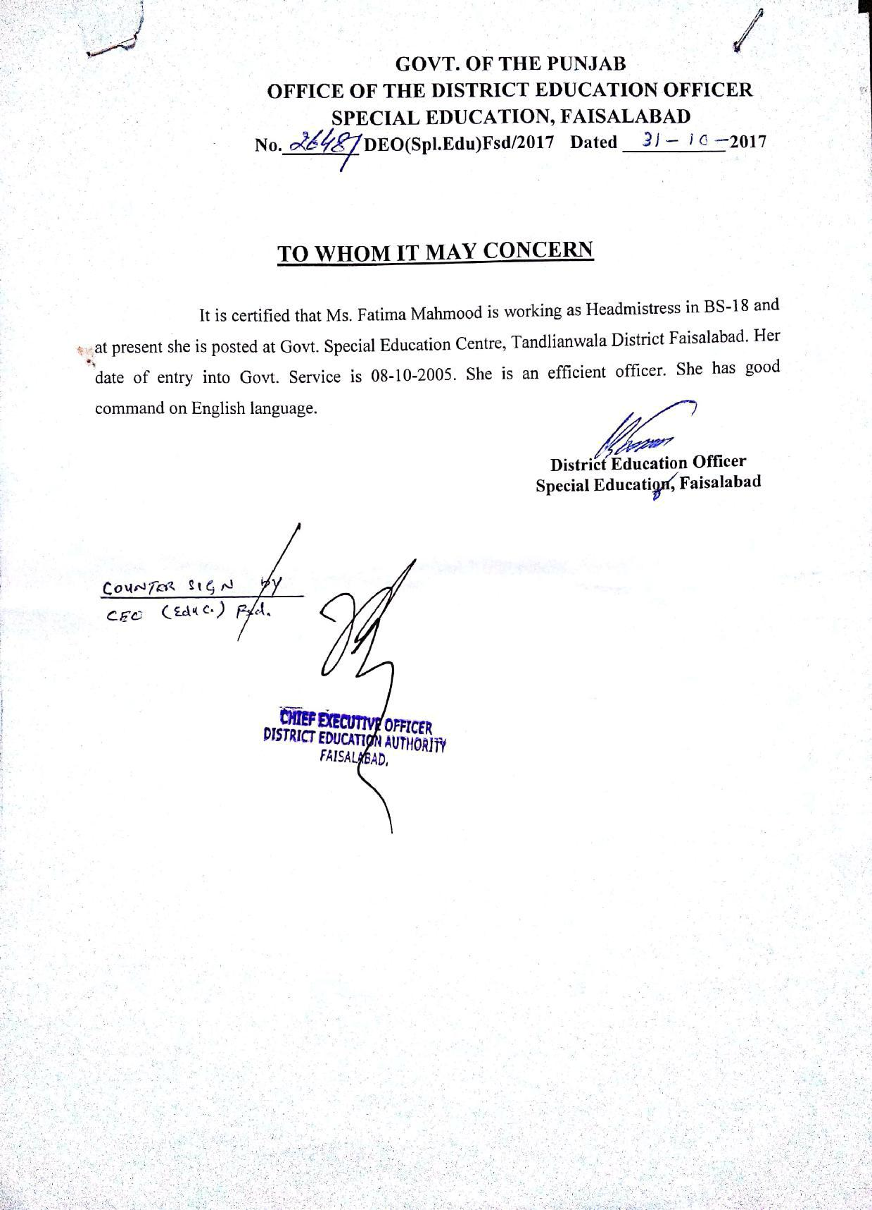





ISSN 2229-5518

CERTIFICATE OF ACCEPTANCE

**International Journal of Scientific & Engineering Research (IJSER)**

THIS IS TO CERTIFY THAT OUR REVIEW BOARD HAS ACCEPTED RESEARCH PAPER OF

Fatima Mahmood

effectiveness

of

special education in educating

disable

children

of

gsec faisalabad

May 27, 2016

Visit us at: **www.ijser.org**

Editor in Chief



CERTIFICATE *of* PUBLICATION

THIS ACKN OWLEDGES TH AT

fatima mahmood ; M shaiq

mahmood

HAS S UCCESS FULLY PUBLIS HED RES EARCH P APER

EFFECTIVENESS OF SPECIAL

EDUCATION IN EDUCATING

DISABLED CHILDREN OF

GSEC FAISALABAD

|  |  |  |  |  |
| --- | --- | --- | --- | --- |
| MAY | *|* |  |  |  |
| 2016 |  | |  |  |
|  | |  |  |
| Members | IJSER Review Board Panel | www.ijser.org | |  |  |
|  |  |  |  |  |

**WWW.IJSER.ORG**

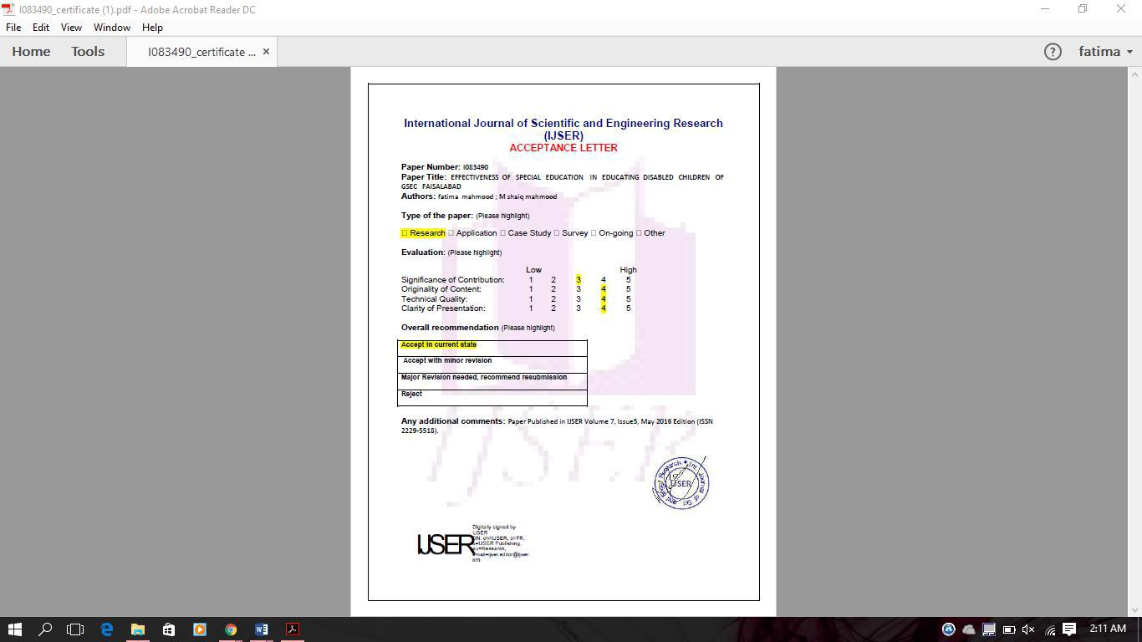



Fatima Mahmood

**30/12/2017**



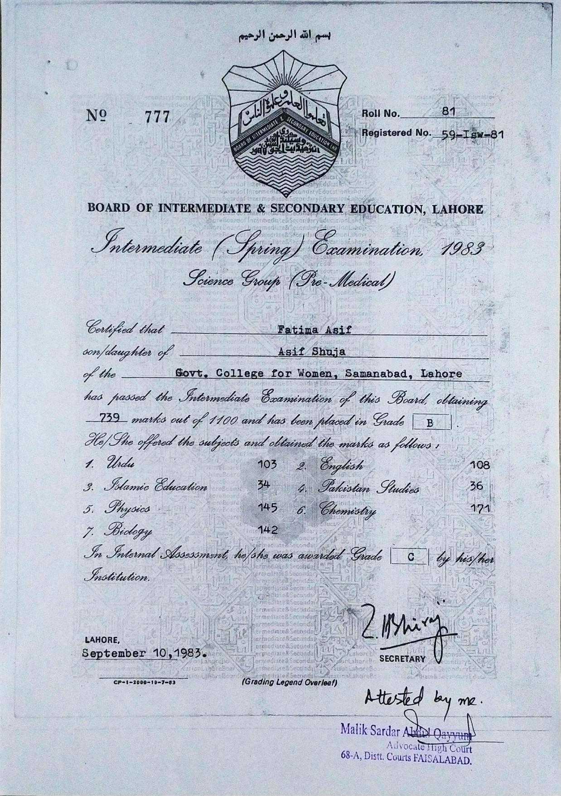

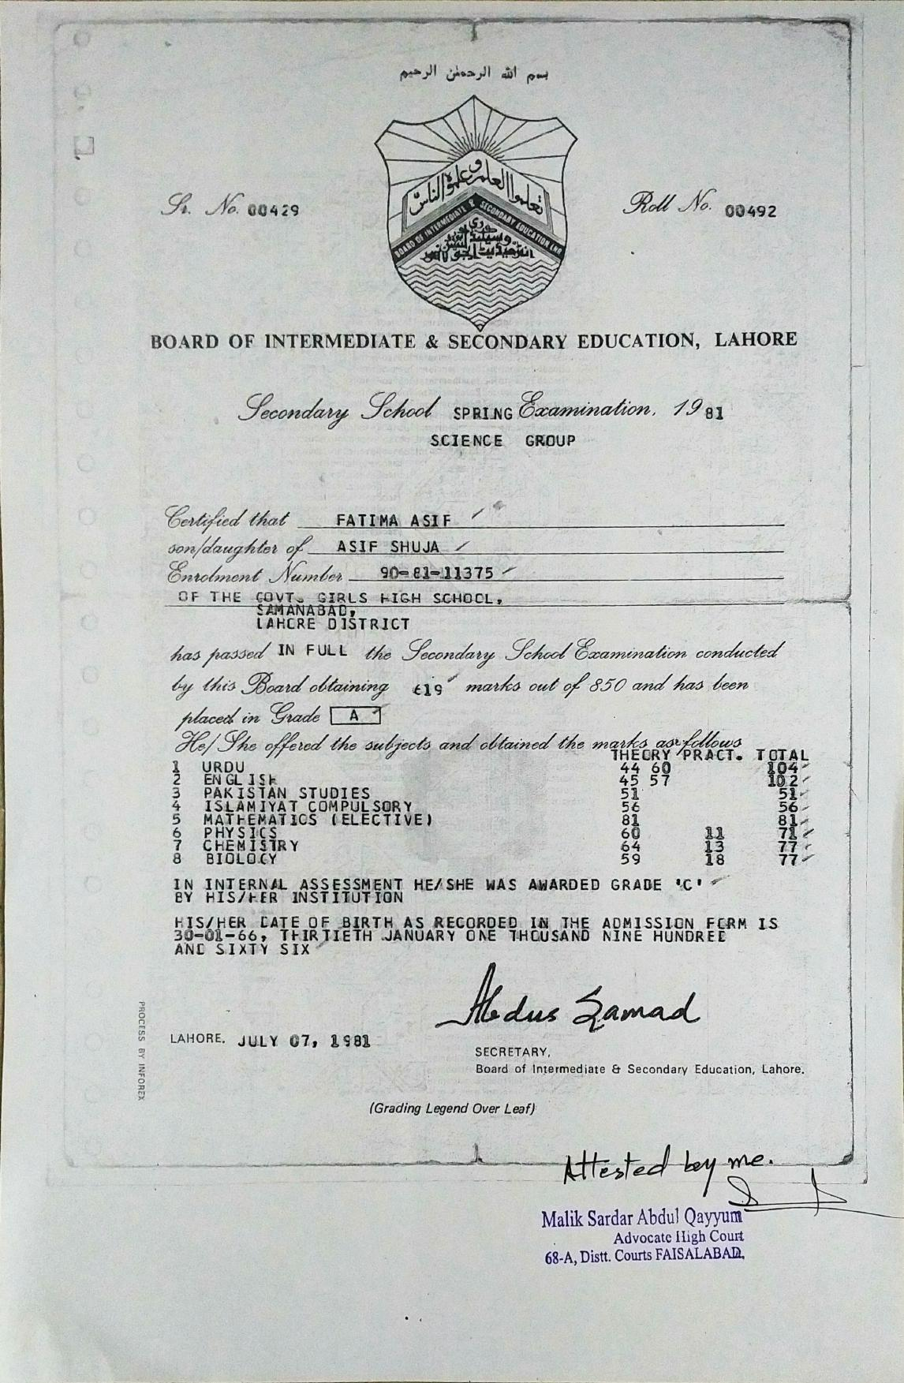

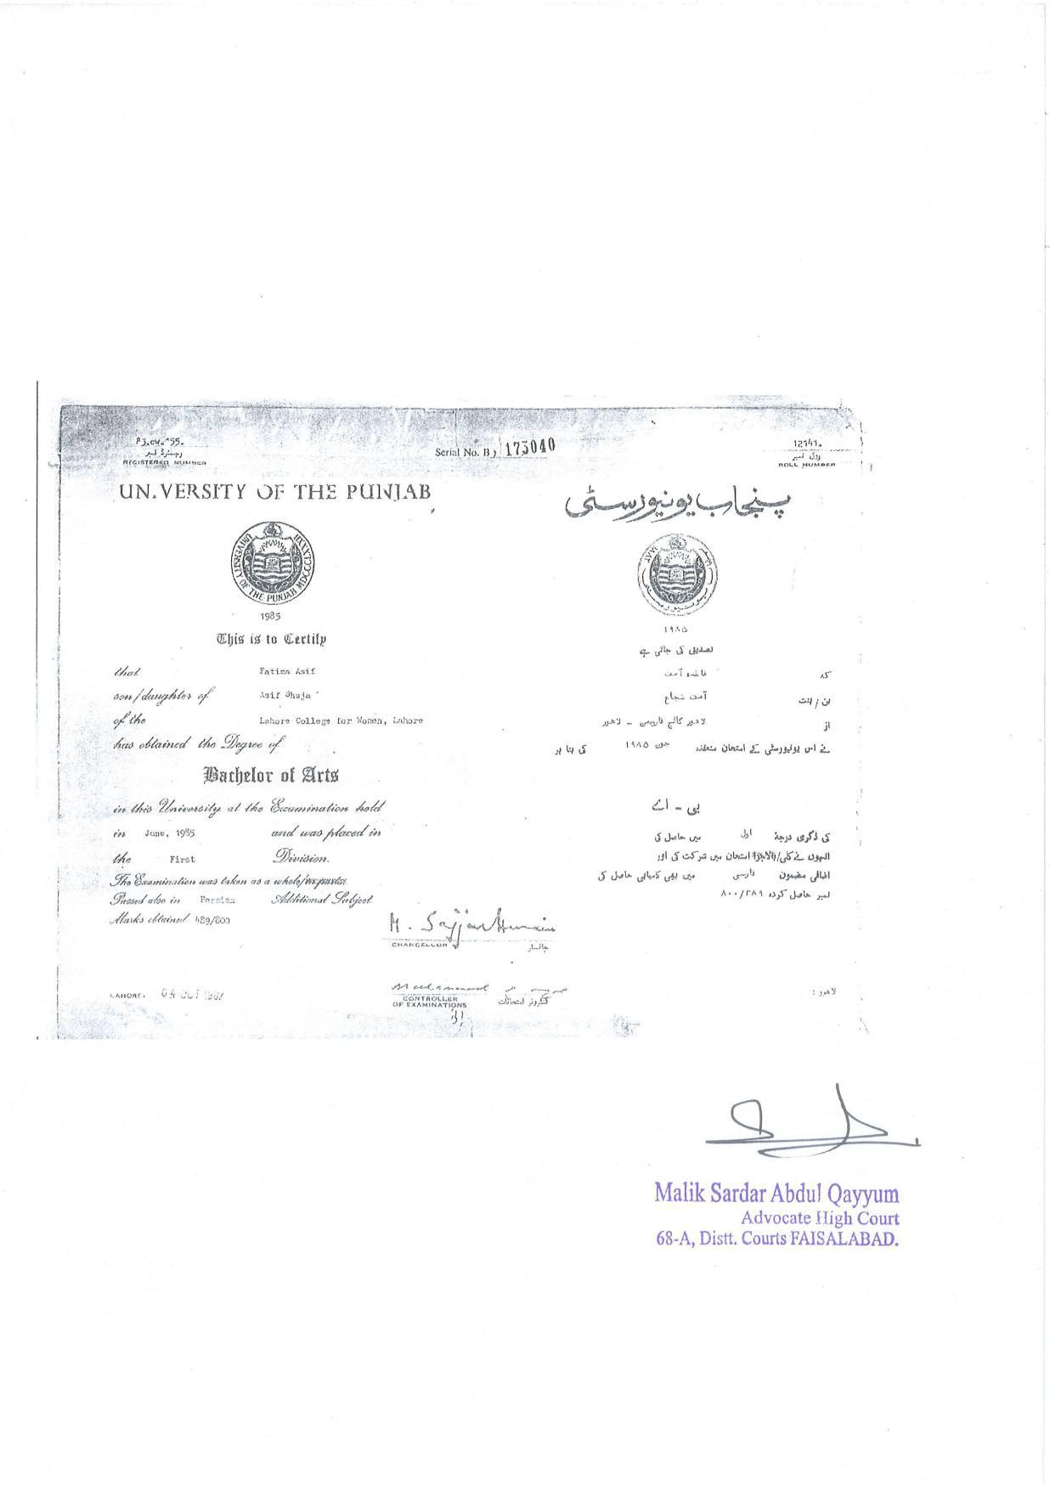

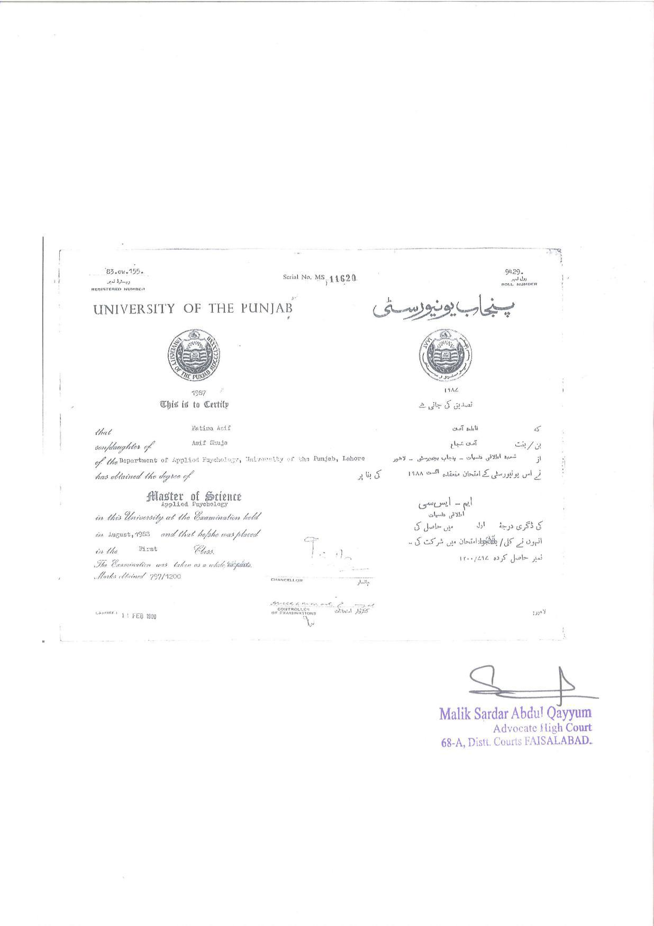



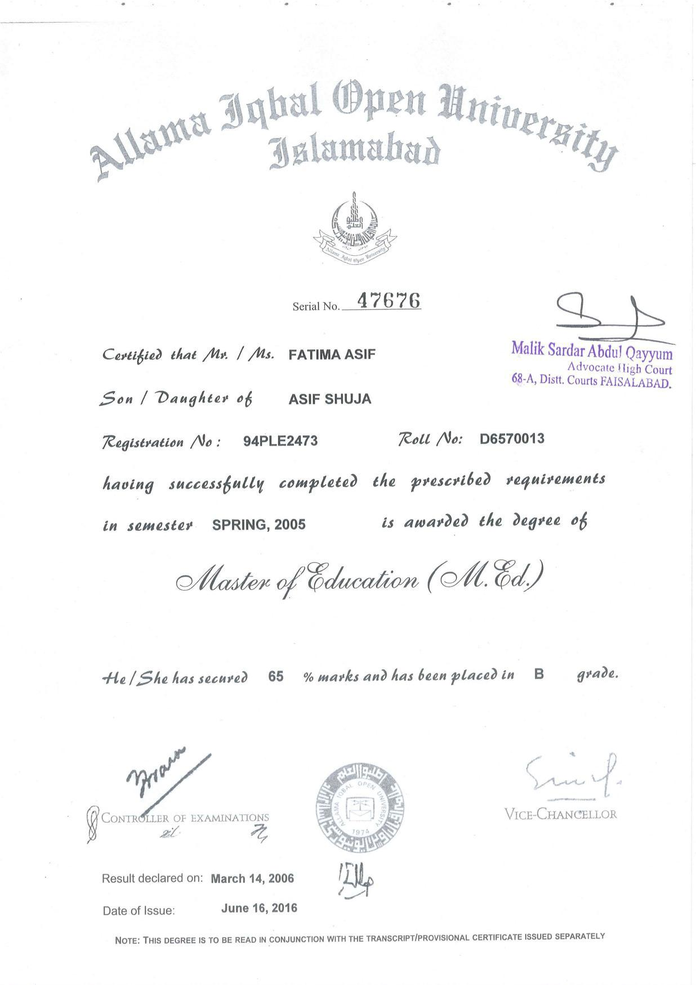



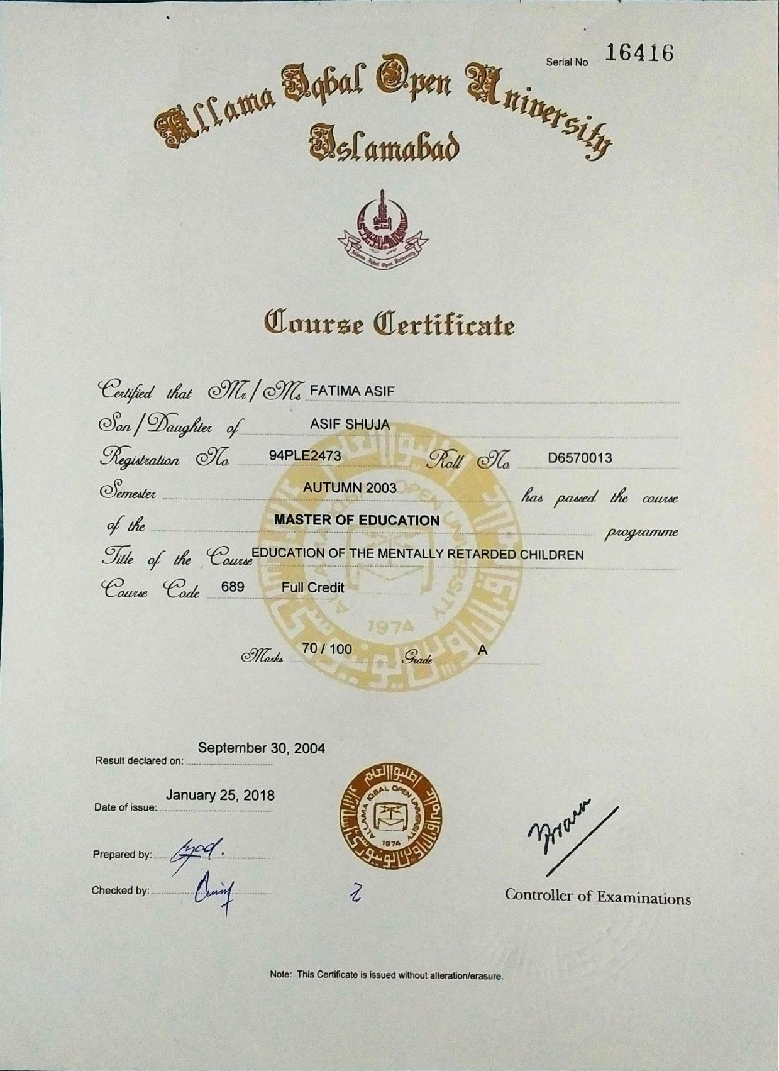

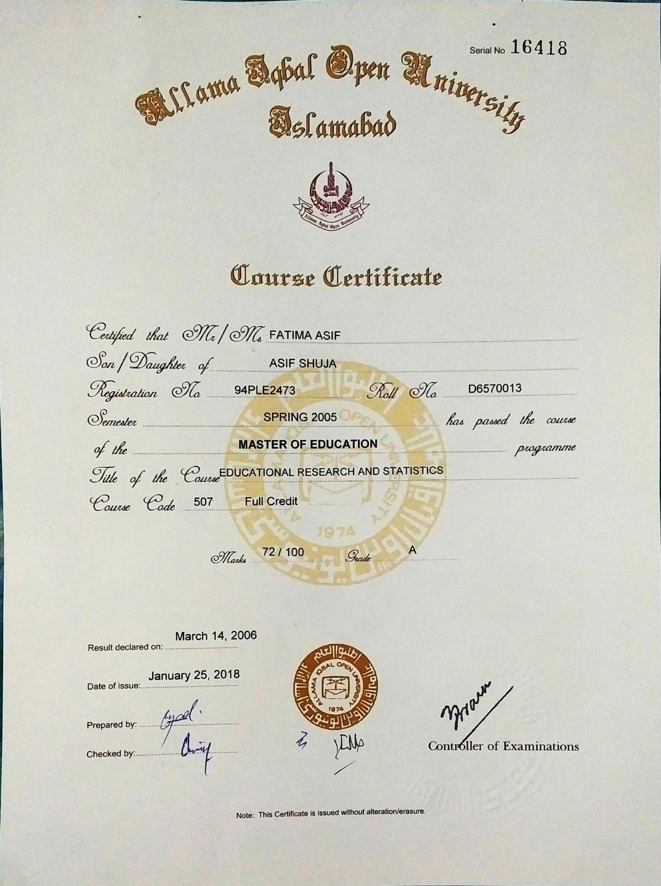

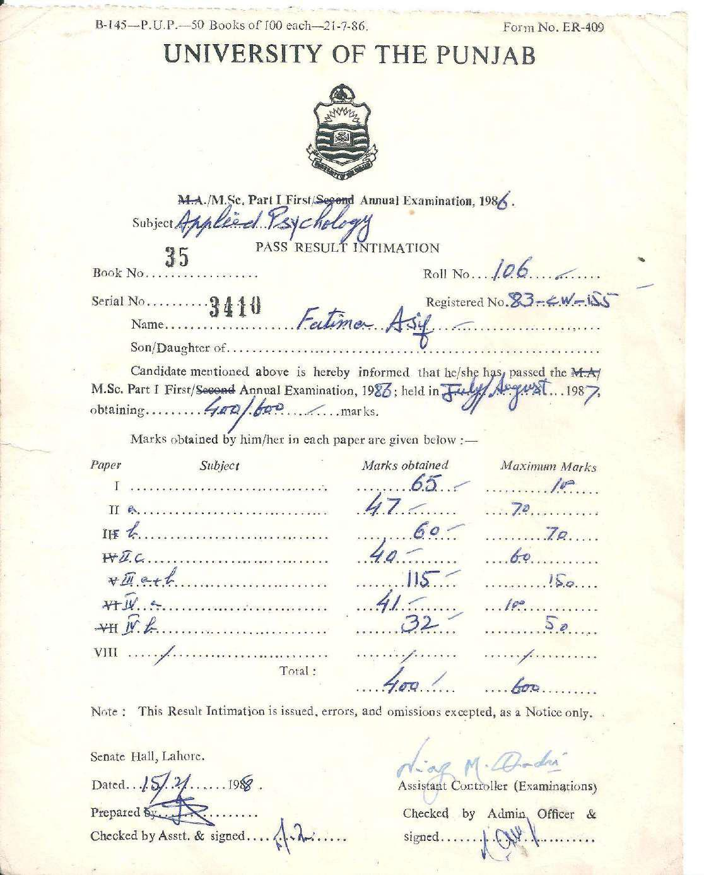

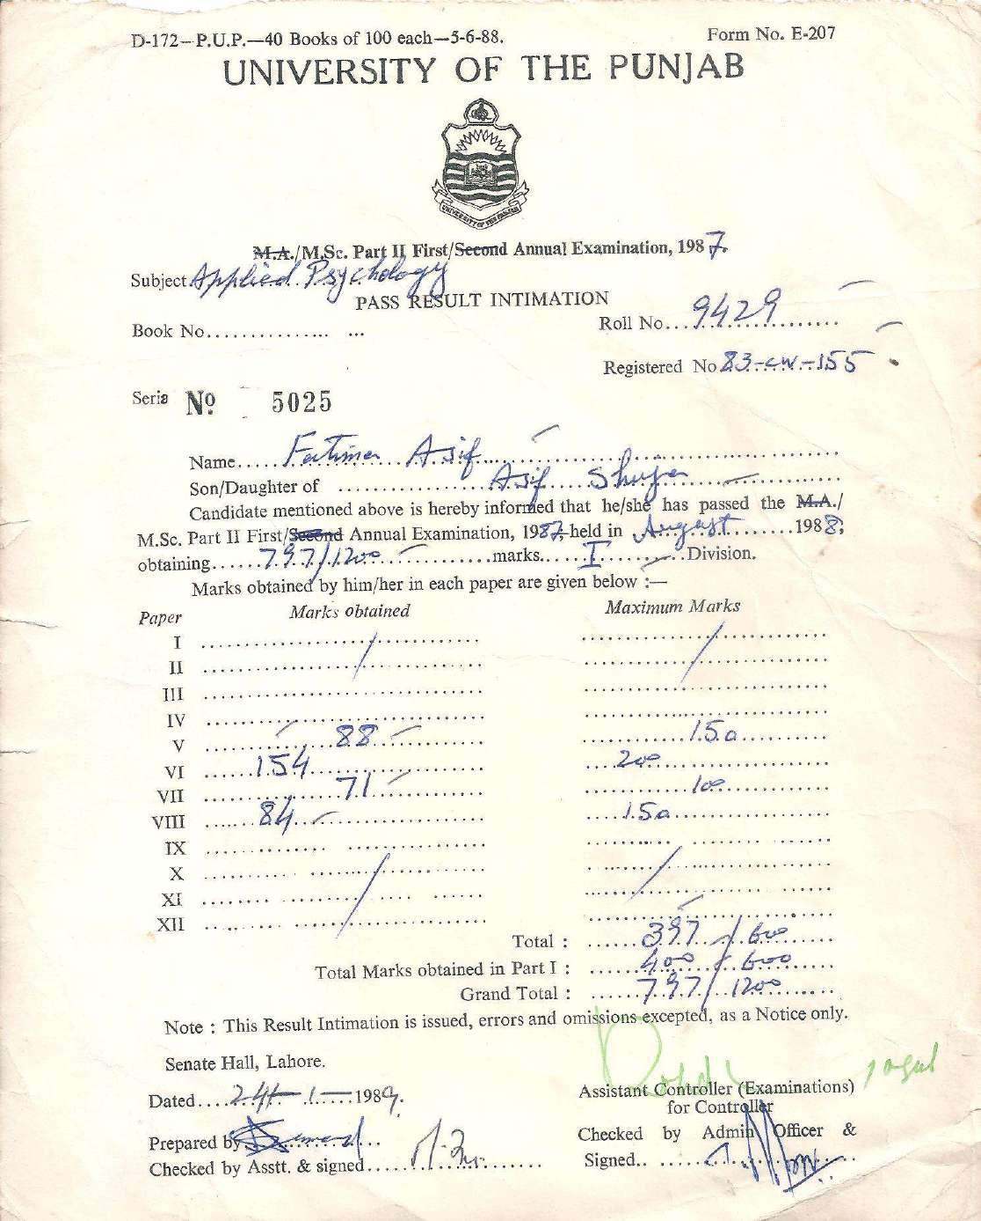



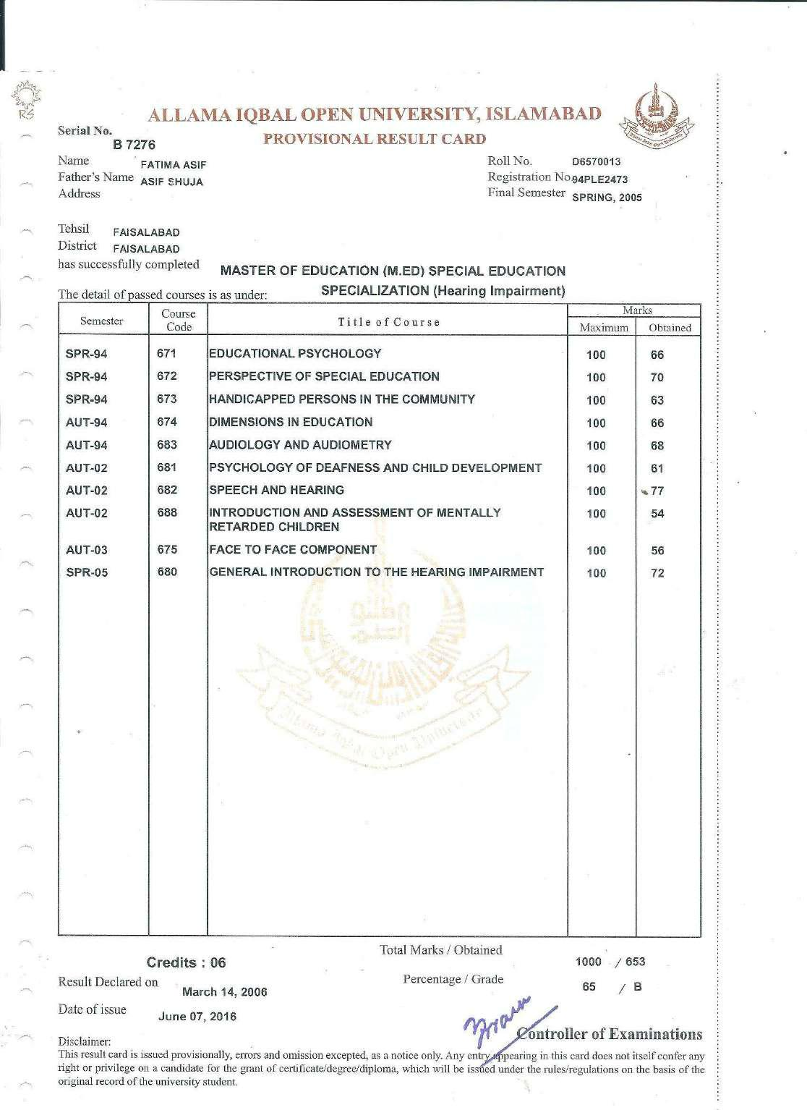

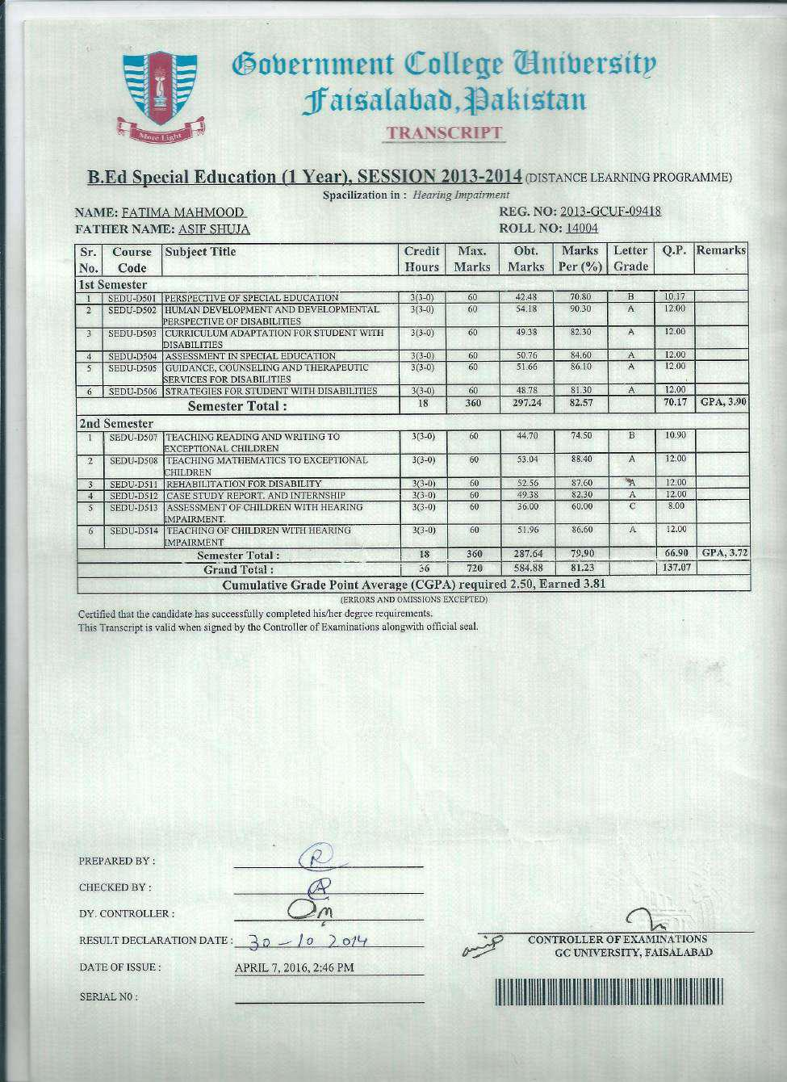

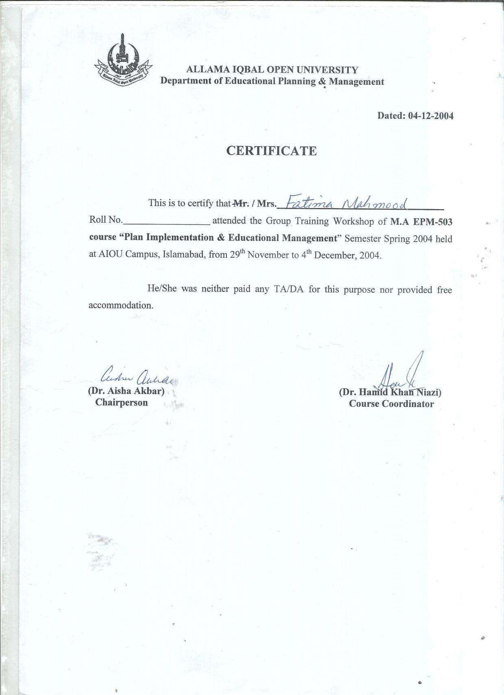

Powered by TCPDF (www.tcpdf.org)

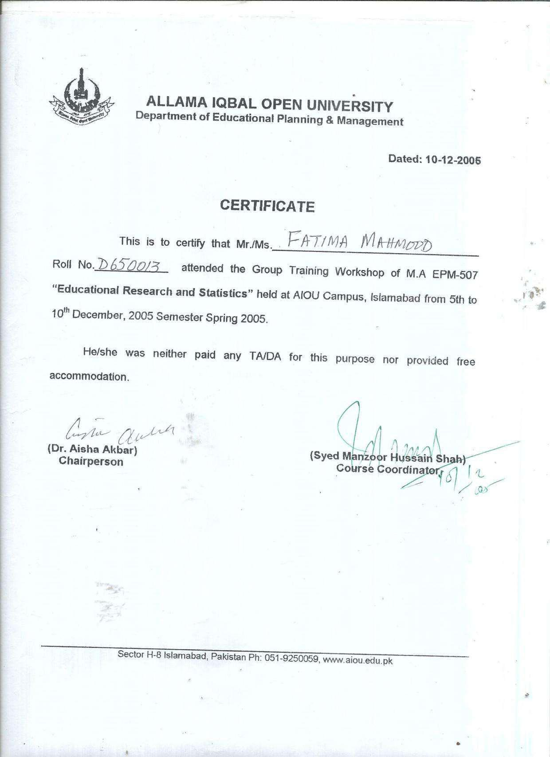

Powered by TCPDF (www.tcpdf.org)

